EASTERN INTERNATIONAL UNIVERSITY **Practice Assignment – Quarter 1, 2024-2025**

**SCHOOL OF COMPUTING Course Name:** Database

**AND INFORMATION TECHNOLOGY** **Course Code:** CSE 301

🙙🕮🙛 **Student’s Full Name:**

**Practice Assignment 6**

**Student ID:**

***Instruction*:**

*\* Students are allowing to write their answers (like SQL queries, Screen shot of outputs, etc.) in word file (Answer sheet) provided by instructor. After finishing the assignment, students must convert the word file (Answer sheet) into a PDF file. Finally, students upload the file in Moodle.*

1. Use salemanagement database and do following tasks:
   1. Add, delete, update value for the columns in table related to calculate new values and constraint.

|  |
| --- |
| ***Note: executing the UPDATE command: In MySQL Workbench if announcement is 1175 error.***   1. Go to Edit --> Preferences 2. Click "SQL Editor" tab and uncheck "Safe Updates" check box 3. Query --> Reconnect to Server // logout and then login 4. Now execute your SQL query   **Or SET SQL_SAFE_UPDATES = 0;** |

* + 1. How to check constraint in a table?

Example:

SELECT CONSTRAINT_NAME, CONSTRAINT_TYPE

FROM INFORMATION_SCHEMA.TABLE_CONSTRAINTS

WHERE TABLE_NAME = 'salesman';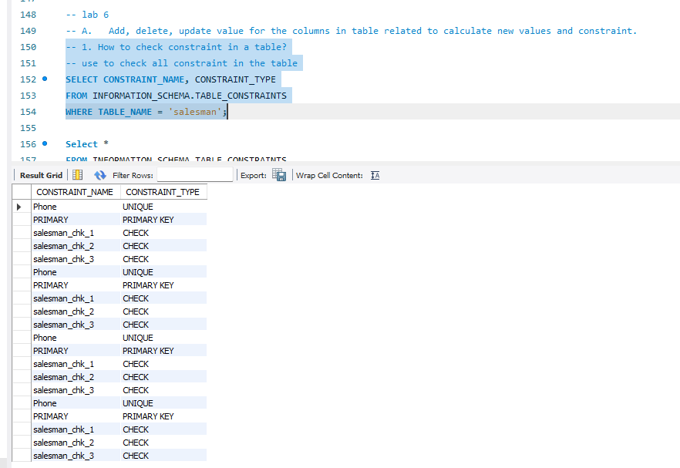

* + 1. Create a separate table name as “ProductCost” from “Product” table, which contains the information about product name and its buying price. 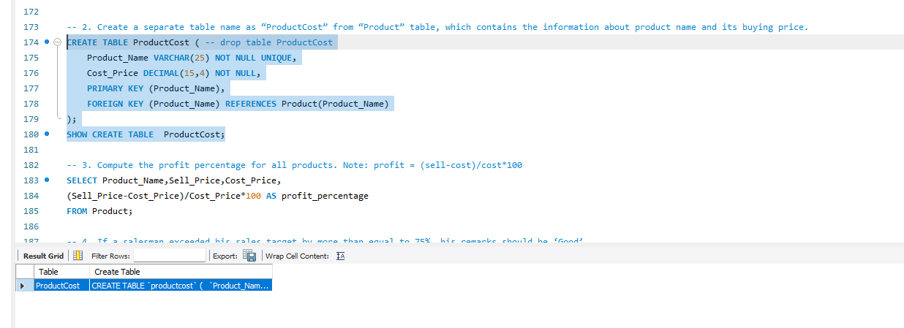
    2. Compute the profit percentage for all products. Note: profit = (sell-cost)/cost*100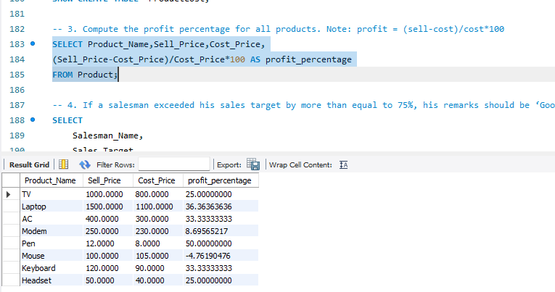
    3. If a salesman exceeded his sales target by more than equal to 75%, his remarks should be ‘Good’.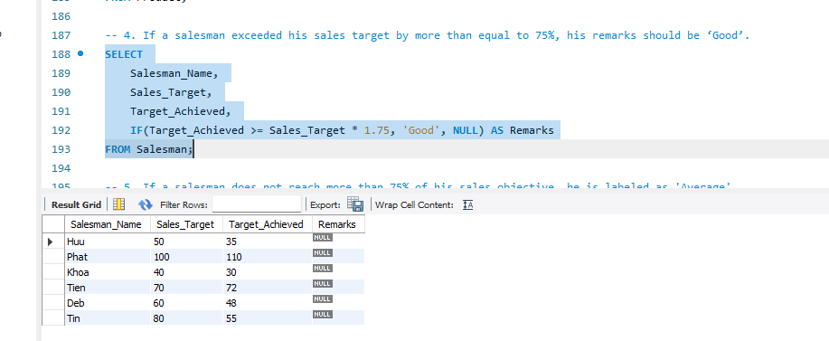
    4. If a salesman does not reach more than 75% of his sales objective, he is labeled as 'Average'.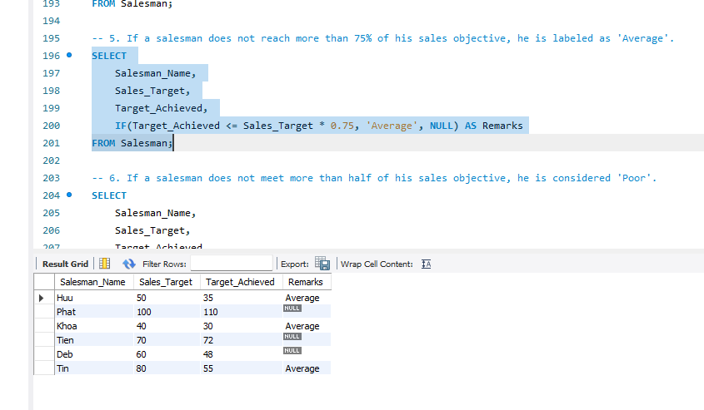
    5. If a salesman does not meet more than half of his sales objective, he is considered 'Poor'.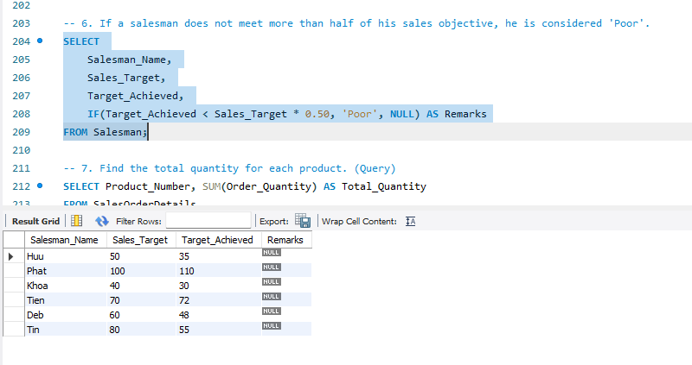
    6. Find the total quantity for each product. (Query)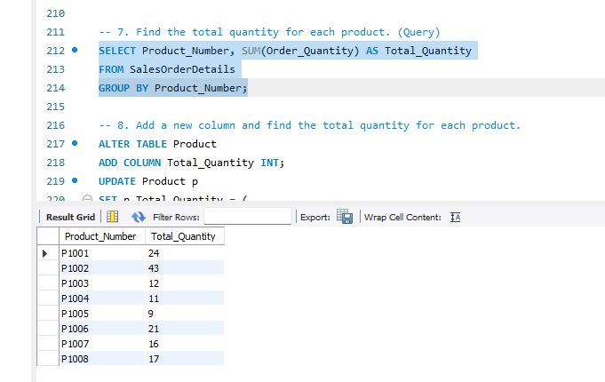
    7. Add a new column and find the total quantity for each product.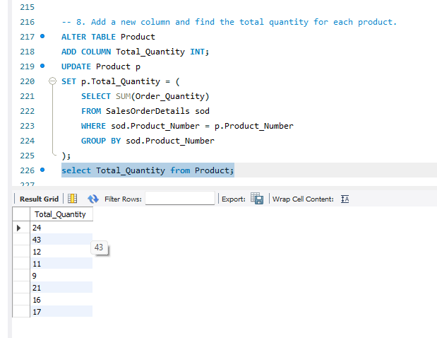
    8. If the Quantity on hand for each product is more than 10, change the discount rate to 10 otherwise set to 5.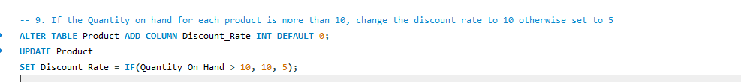
    9. If the Quantity on hand for each product is more than equal to 20, change the discount rate to 10, if it is between 10 and 20 then change to 5, if it is more than 5 then change to 3 otherwise set to 0.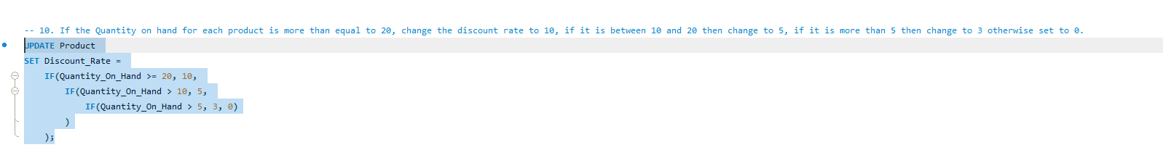 
    10. The first number of pin code in the client table should start with 7.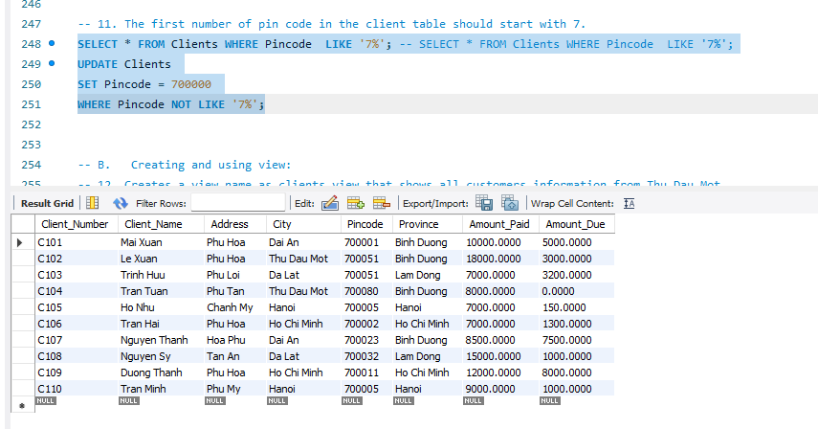
  1. Creating and using view:

|  |
| --- |
| *Statements:*   1. *Creating a view*   CREATE [OR REPLACE] VIEW view_name  AS  select-statement;  **OR REPLACE - added to overwrite the old view with the same name if applicable.**   1. *Changing a view*   ALTER VIEW view_name AS select_statement;   1. *Renaming a view*   RENAME TABLE view_name TO new_view_name;   1. *Deleting a view*   DROP VIEW [IF EXISTS] view_name; |
|  |

* + 1. Creates a view name as clients_view that shows all customers information from Thu Dau Mot.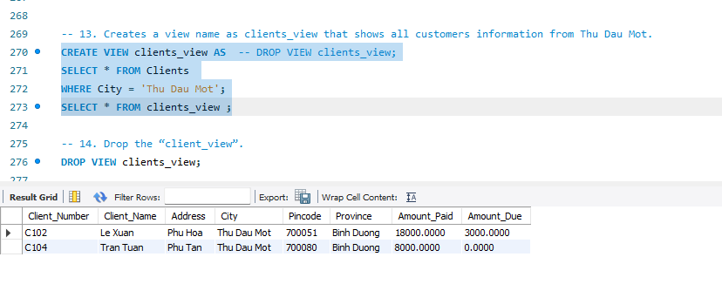
    2. Drop the “client_view”.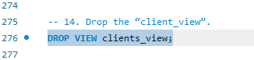
    3. Creates a view name as clients_order that shows all clients and their order details from Thu Dau Mot.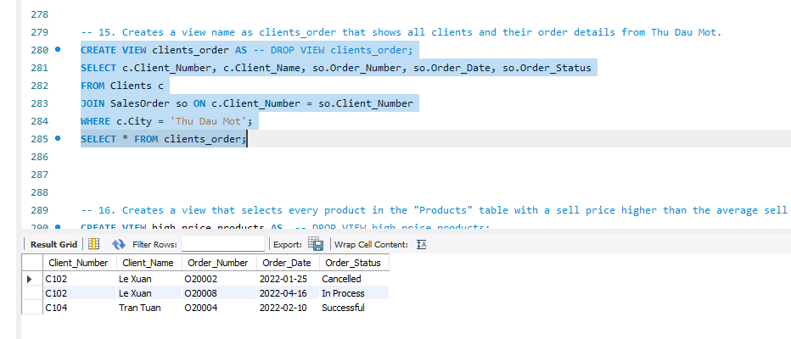
    4. Creates a view that selects every product in the "Products" table with a sell price higher than the average sell price.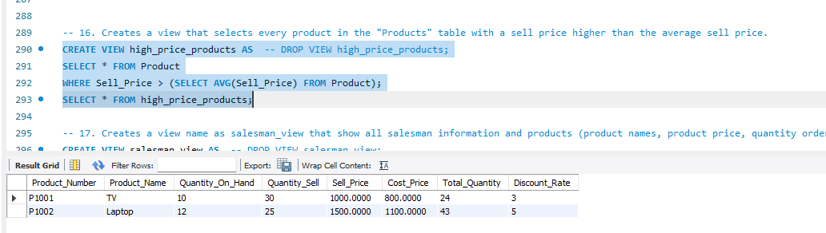
    5. Creates a view name as salesman_view that show all salesman information and products (product names, product price, quantity order) were sold by them.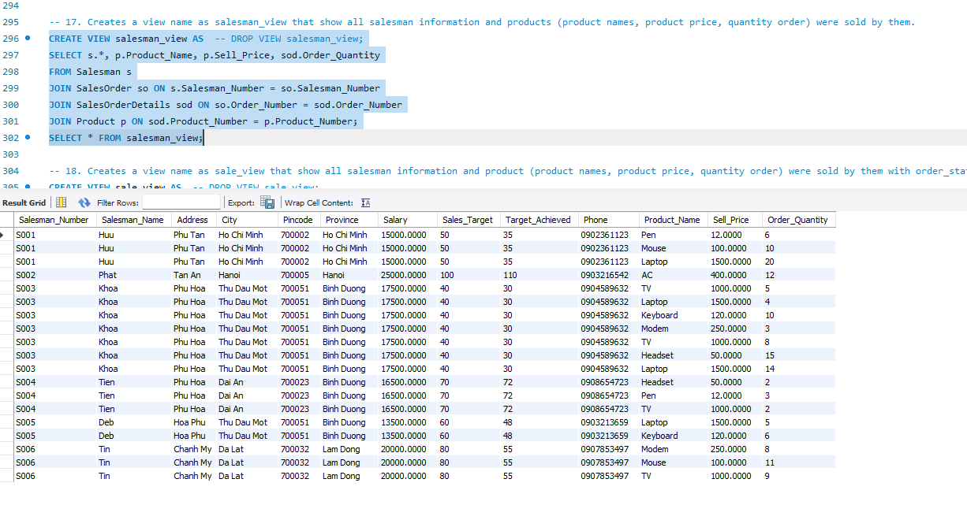
    6. Creates a view name as sale_view that show all salesman information and product (product names, product price, quantity order) were sold by them with order_status = 'Successful'.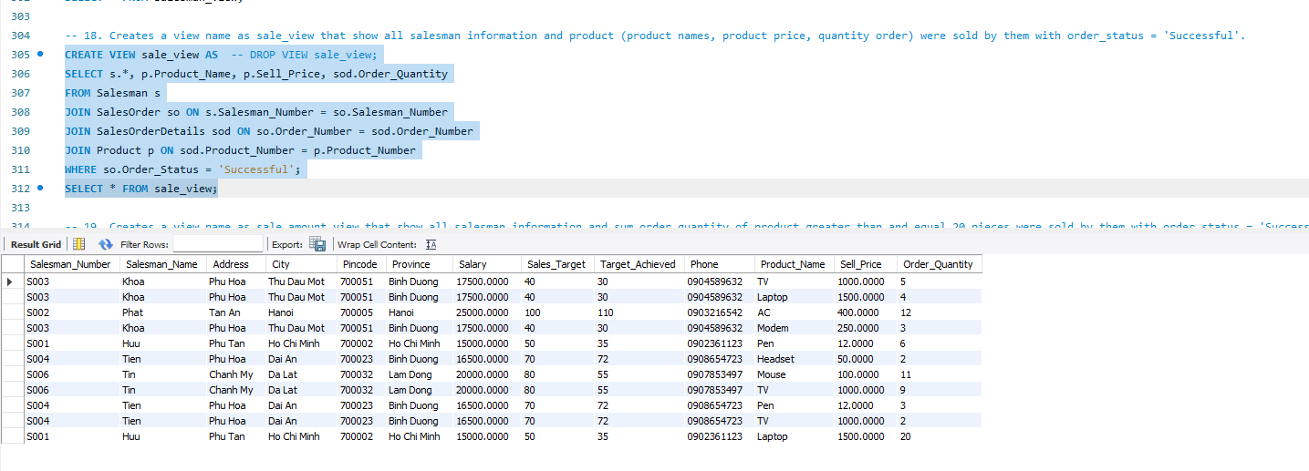
    7. Creates a view name as sale_amount_view that show all salesman information and sum order quantity of product greater than and equal 20 pieces were sold by them with order_status = 'Successful'.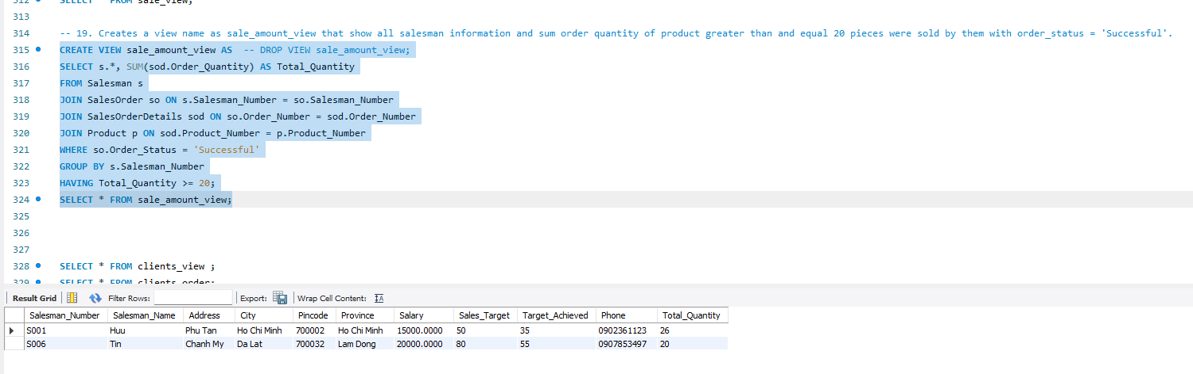

1. Additional assignments about Constraint
   * 1. Amount paid and amounted due should not be negative when you are inserting the data. 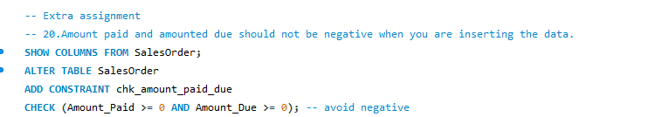
     2. Do not enforce the check constraint for pincode.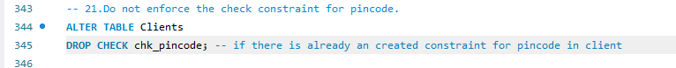
     3. How to alter a check constraint enforcement state?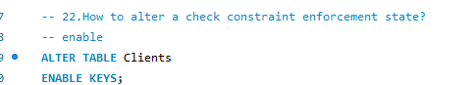
     4. Remove the constraint from pincode;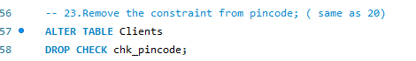
     5. The sell price and cost price should be unique.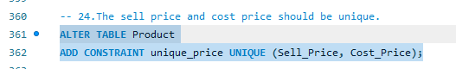
     6. The sell price and cost price should not be unique.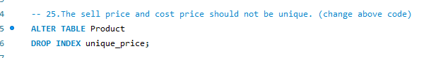
     7. Update the delivery status to “Delivered” for the product number P1007.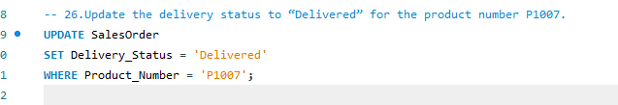
     8. Change address and city to ‘Phu Hoa’ and ‘Thu Dau Mot’ where client number is C104.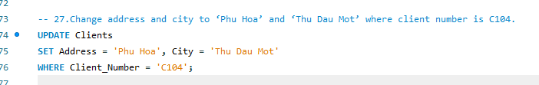
     9. Add a new column to “Product” table named as “Exp_Date”, data type is Date.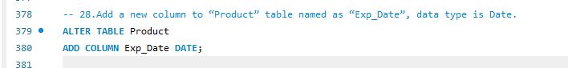
     10. Add a new column to “Clients” table named as “Phone”, data type is varchar and size is 15.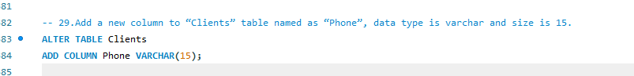
     11. Update remarks as “Good” for all salesman.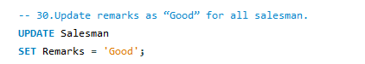
     12. Change remarks to "bad" whose salesman number is "S004".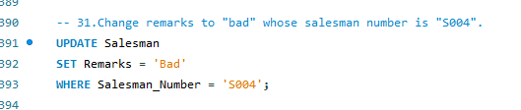
     13. Modify the data type of “Phone” in “Clients” table with varchar from size 15 to size is 10.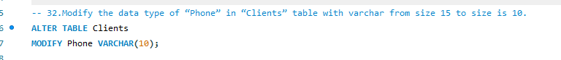
     14. Delete the “Phone” column from “Clients” table.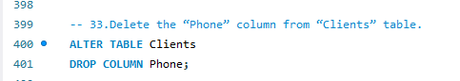
     15. alter table Clients drop column Phone;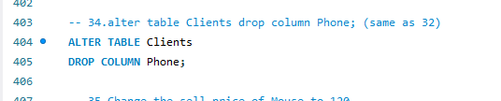
     16. Change the sell price of Mouse to 120.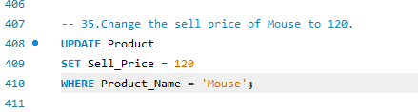
     17. Change the city of client number C104 to “Ben Cat”.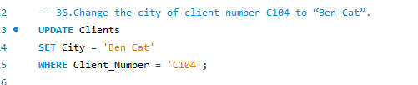
     18. If Order_Quantity greater than 5, then 10% discount. If Order_Quantity greater than 10, then 15% discount. Othrwise, no discount.